

# 

### Semester One Examination, 2019

### Question/Answer booklet

# MATHEMATICS

If required by your examination administrator, please place your student identification label in this box

**METHODS**

**UNIT 3**

## Section One:

## Calculator-free

|  |  |  |  |  |  |  |  |  |  |  |
| --- | --- | --- | --- | --- | --- | --- | --- | --- | --- | --- |
| Student number: In figures |  |  |  |  |  |  |  |  |  |  |

In words

Your name

## Time allowed for this section

Reading time before commencing work: five minutes

Working time: fifty minutes

## Materials required/recommended for this section

***To be provided by the supervisor***

This Question/Answer booklet

Formula sheet

***To be provided by the candidate***

Standard items: pens (blue/black preferred), pencils (including coloured), sharpener,  
correction fluid/tape, eraser, ruler, highlighters

Special items: nil

## Important note to candidates

No other items may be taken into the examination room. It is **your** responsibility to ensure that you do not have any unauthorised material. If you have any unauthorised material with you, hand it to the supervisor **before** reading any further.

## Structure of this paper

|  |  |  |  |  |  |
| --- | --- | --- | --- | --- | --- |
| Section | Number of questions available | Number of questions to be answered | Working  time (minutes) | Marks available | Percentage of examination |
| Section One:  Calculator-free | 8 | 8 | 50 | 52 | 35 |
| Section Two:  Calculator-assumed | 13 | 13 | 100 | 98 | 65 |
|  | | |  | **Total** | 100 |

## Instructions to candidates

1. The rules for the conduct of examinations are detailed in the school handbook. Sitting this examination implies that you agree to abide by these rules.

2. Write your answers in this Question/Answer booklet preferably using a blue/black pen.  
Do not use erasable or gel pens.

3. You must be careful to confine your answer to the specific question asked and to follow any instructions that are specified to a particular question.

4. Show all your working clearly. Your working should be in sufficient detail to allow your answers to be checked readily and for marks to be awarded for reasoning. Incorrect answers given without supporting reasoning cannot be allocated any marks. For any question or part question worth more than two marks, valid working or justification is required to receive full marks. If you repeat any question, ensure that you cancel the answer you do not wish to have marked.

5. It is recommended that you do not use pencil, except in diagrams.

6. Supplementary pages for planning/continuing your answers to questions are provided at the end of this Question/Answer booklet. If you use these pages to continue an answer, indicate at the original answer where the answer is continued, i.e. give the page number.

7. The Formula sheet is not to be handed in with your Question/Answer booklet.

Section One: Calculator-free 35% (52 Marks)

This section has**eight (****8)** questions. Answer **all** questions. Write your answers in the spaces provided.

Working time: 50 minutes.

Question 1 (6 marks)

The curve shown below passes through the point $(1, 10)$ and is such that $\begin{matrix}dy \\ \overline{dx}\end{matrix}=\begin{matrix}8 \\ \overline{x^{3}}\end{matrix}$.

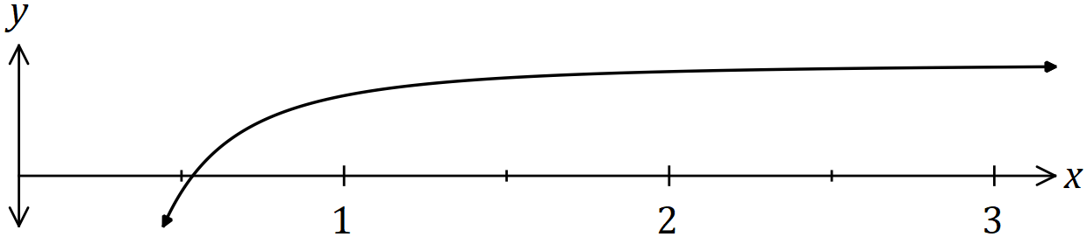

(a) Determine the equation of the curve. (3 marks)

(b) Determine the area of the region enclosed by the curve, the $x$-axis, the line $x=1$ and the line $x=2$. (3 marks)

Question 2 (7 marks)

(a) Determine

(i) $\begin{matrix}d \\ \overline{dx}\end{matrix}\left(\begin{matrix}e^{6x-1} \\ \overline{\sin\left(π-3x\right)}\end{matrix}\right)$. (3 marks)

(ii) $\begin{matrix}d \\ \overline{dt}\end{matrix}\int_{t}^{3}{\underset{ }{\overset{ }{{(5θ-2)}^{6} }}}dθ$. (2 marks)

(b) Simplify the indefinite integral $\int_{ }^{ }{\underset{ }{\overset{ }{{(2x-7)}^{4} }}}dx$. (2 marks)

Question 3 (7 marks)

A calculator program will generate a single random integer $n$, where $3≤n≤12$. The program is run once, and the random variable $X$ is the number of fours or fives obtained.

(a) Explain why $X$ is a Bernoulli random variable. (1 mark)

(b) Determine $P(X=1)$. (1 mark)

(c) Determine the mean and standard deviation of $X$. (2 marks)

The random variable $Y$ is the number of fours or fives obtained in three consecutive runs of the program.

(d) Determine $P(Y≤1)$. (3 marks)

Question 4 (5 marks)

Let $f\left(x\right)=5x+\begin{matrix}k \\ \overline{2x}\end{matrix}$, $x<0$ and $k$ is a constant. The graph of $y=f(x)$ has a stationary point when $x=-3$.

(a) Determine the value of $k$. (2 marks)

(b) Use the second derivative test to determine the nature of the stationary point. (3 marks)

Question 5 (7 marks)

A farmer keeps a brood of $n$ hens that can each lay up to one egg per day. On any given day, the probability that a hen lays an egg is independent with a constant value of $p$.

The discrete random variable $X$ is the number of eggs laid by the brood in one day and $X$ has a mean of $7.2$ and standard deviation of $1.2$.

(a) State the name given to this type of probability distribution and briefly explain why it is discrete. (2 marks)

(b) Determine the value of $n$ and the value of $p$. (3 marks)

(c) Determine the mean and variance of the distribution $Y$, where $Y=5X+3.3$. (2 marks)

Question 6 (7 marks)

A curve has equation $y=3xe^{4nx}$, where $n$ is a positive constant.

(a) Determine, in terms of $n$, the coordinates of the stationary point of the curve. (4 marks)

(b) Determine the coordinates of the point of inflection of the curve when $n=\frac{1}{8}$. (3 marks)

Question 7 (6 marks)

A vehicle travelling in a straight line has a velocity of ms-1 as it leaves point $P$. The acceleration of the vehicle is given by ms-2, where is the time in seconds since the vehicle left $P$.

(a) Determine the velocity of the vehicle when $t=3$. (2 marks)

(b) Determine how far from $P$ the vehicle first comes to rest for $t>0$. (4 marks)

Question 8 (7 marks)

(a) Determine $\begin{matrix}d \\ \overline{dx}\end{matrix}\left(2x\sqrt{4+x}\right)$. (2 marks)

(b) Part of the graph of $y=\begin{matrix}x \\ \overline{\sqrt{4+x}}\end{matrix}$ is shown below.

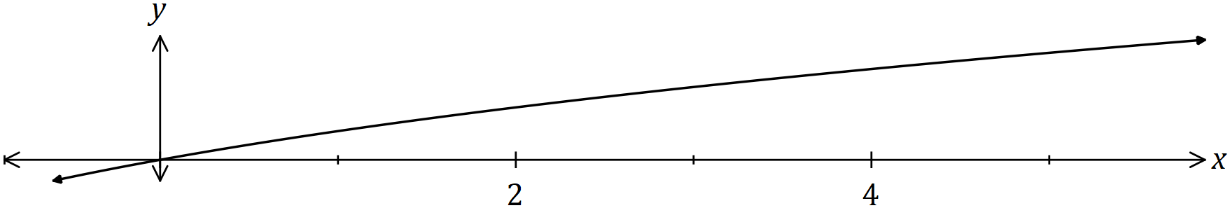

Using your answer from part (a) or otherwise, determine $\int_{0}^{5}{\underset{ }{\overset{ }{\begin{matrix}x \\ \overline{\sqrt{4+x}}\end{matrix}}}}dx$. (5 marks)

Supplementary page

Question number: _________

|  |  |  |
| --- | --- | --- |
| Markers use only | | |
| Question | Maximum | Mark |
| 1 | 6 |  |
| 2 | 7 |  |
| 3 | 7 |  |
| 4 | 5 |  |
| 5 | 7 |  |
| 6 | 7 |  |
| 7 | 6 |  |
| 8 | 7 |  |
| S1 Total | 52 |  |
| S1 Wt (×0.6731) | 35% |  |
| S2 Wt | 65% |  |
| Total | 100% |  |

Student Name: ____________________________________________

© 2019 WA Exam Papers. All Saints' College has a non-exclusive licence to copy and communicate this document for non-commercial, educational use within the school. No other copying, communication or use is permitted without the express written permission of WA Exam Papers. SN001-135-1.